**Exercise 3. The outputs after running the code for the Langevin_BBK algorithm were shown below**.

In [**33**]: runfile('/Users/melissasuchanek/Desktop/Figen Files/BBK-Langevin.py', wdir='/Users/melissasuchanek/Desktop/Figen Files')

[1.06013853 1.31137316 1.56260779 1.81384242 2.06507705 2.31631168

2.56754631 2.81878094 3.07001557 3.3212502 3.57248484 3.82371947

4.0749541 4.32618873 4.57742336 4.82865799 5.07989262 5.33112725

5.58236188 5.83359651]

[-107.1389493226, -110.8762342308, -112.2035650482, -112.6221628016, -112.6993448642, -112.6532021548, -112.5695515418, -112.4825450847, -112.4093307577, -112.3611216888, -112.3328706063, -112.3154788092, -112.3040496673, -112.0685479896, -112.2907699794, -112.2869226228, -112.0012243902, -111.9483767861, -111.927401279, -112.2798664306]

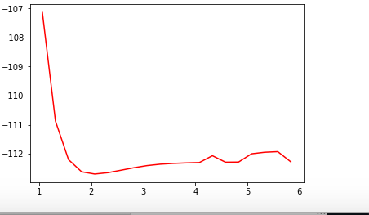

Figure1. r_array versus E_array

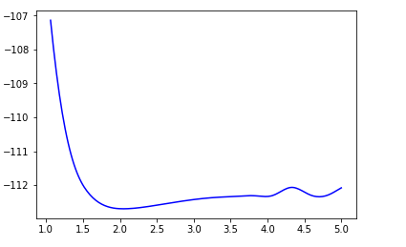

Figure 2. Interpolated r_array versus interpolated E_array

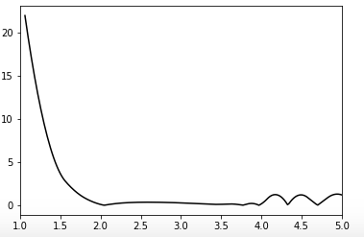

Figure 3. First derivative of potential energy (Force is the negative of the derivative)

Equilibrium bond length is 2.049949748743719 atomic units

Equilibrium bond length is 1.0844234170854272 Angstroms

Energy of vibration is 0.3090818782598616 eV

Reduced mass is 13625.0 atomic units

Vibrational frequency is 0.01135871075152922 atomic units

Initial separation is 3.1408644330478683 atomic units

Initial velocity is 0.00018958140373020581 atomic units

force factor is 1.7579017228903373 atomic units

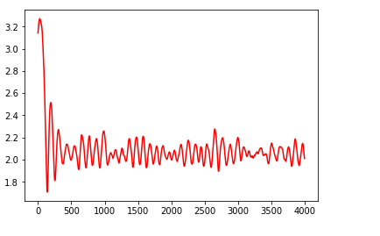

Figure 4. The trajectory of bond length vs time

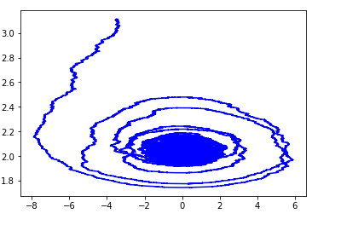 Figure 5. The phase space trajectory of position vs momentum (for not isolated CO molecule system)

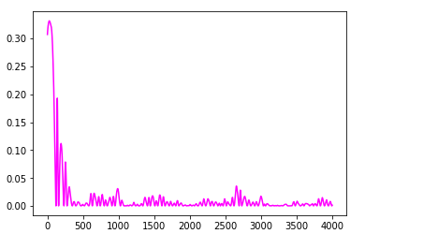

Figure 6. The total energy vs. time

Mean Energy for next to last 100000 time steps of the trajectory is 0.0025013023043660514 Hartrees

Mean Energy for last 100000 time steps of the trajectory is 0.005655634119364834 Hartrees

1) One of the differences we see from last week’s calculations are that comparison of space trajectory of position vs. momentum for isolated CO molecule system (Figure 7) to the phase space trajectory of position vs. momentum for not isolated CO molecule system (Figure 5). The momentum has changed by “drag” and “Gaussian random perturbations”, which gives asymptotic behavior to the system on the trajectory for not isolated CO molecule system (Fig.5). Figure 7 is smooth, round, regular, symmetrical shape. Figure 5 is not smooth and not symmetrical. Also, the energies converge into steady state .

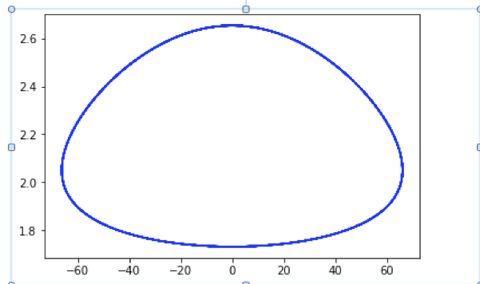

Figure 7. Space trajectory of position vs. momentum(for isolated CO molecule system)

2) As it can be seen from Figure 6, our system reaches thermal equilibrium with a well-defined temperature and energies seem to converge to steady state.

3) In our non-isolated system, the energy is not constant. But the average energy still reflects the temperature. If the system has well defined temperature, we can expect our total energy (kinetic +potential) to have an average value of kBT. This average should be the same (Ergodic hypothesis) whether we calculate it as a time average for a single molecule or as an ensemble average for a collection of molecules. In our system, the well-defined temperature converges the temperature used in the simulation. However, the temperature obtained based on the average energy trajectory calculated with BBK algorithm may not be the temperature actually used in the calculation.